 | National Junior College  SH2 Preliminary Examinations for General Certificate of Education Advanced Level  Higher 2
GEOGRAPHY |  | 9173/01
Paper 1
INSERT |  | 22 August 2024  3 hours
READ THESE INSTRUCTIONS FIRST

This Insert contains all the Resources referred to in the questions.

This document consists of 8 printed pages.
Resource 1 for Question 1
Solar power projects in India in 2017

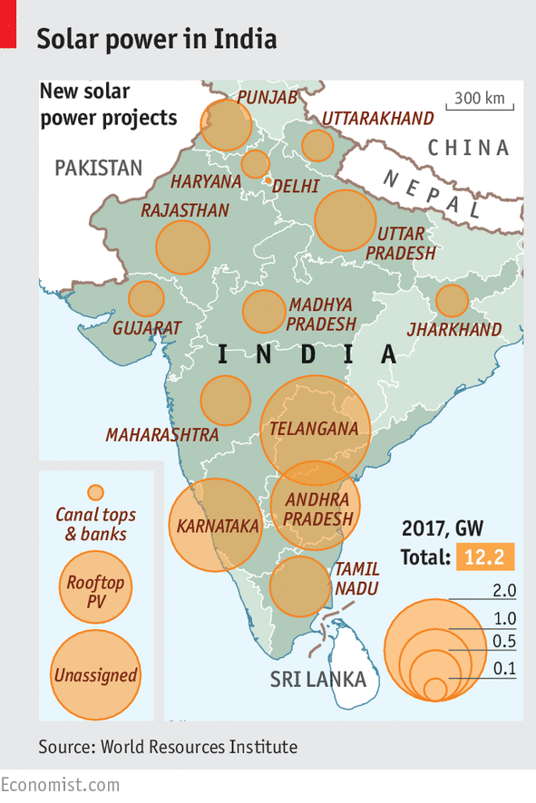

Solar power generated in gigawatts (GW)
Names shown are states with solar power projects installed

Resource 2 for Question 1
Article on solar energy in India
India Is Using More Solar Energy—but It Carries a Lead Risk

Fast-growing nations like India are expected to rapidly increase their use of planet-warming fossil fuels in coming decades—but the adoption of renewable alternatives could help to dampen the environmental and climate impacts as their economies expand. While grid connectivity is reliable and rooftop solar installations do not need lead batteries for on-site storage in many bigger Indian cities like Mumbai and New Delhi, in smaller towns and remote rural areas, connection to the national electricity grid is poor. Many villages get electricity for only two or five hours a day, and the power supply from the grid is erratic and unpredictable, meaning that many solar projects in these areas continue to be heavily reliant on lead-acid batteries for storing unused solar power.

Hence, experts are concerned that the crude methods used by the informal sector for lead recovery could potentially result in millions of tonnes of lead being released into the environment globally – particularly with the rapid expansion of solar installations in small, developing locales.

As in most developing countries, recycling of lead-acid batteries in India is not adequately regulated to protect public health. This results in lead being released back into the environment. While the impacts of prolonged lead exposure are extremely well known, those working in or living near recycling plants are not always aware of the dangers, which include higher risks of cardiovascular disease and high blood pressure. The heavy metal can also cause damage to the kidneys, reproductive system, and the central nervous system.

Resource 3 for Question 1
China’s Himalayan ‘super dam’ plan
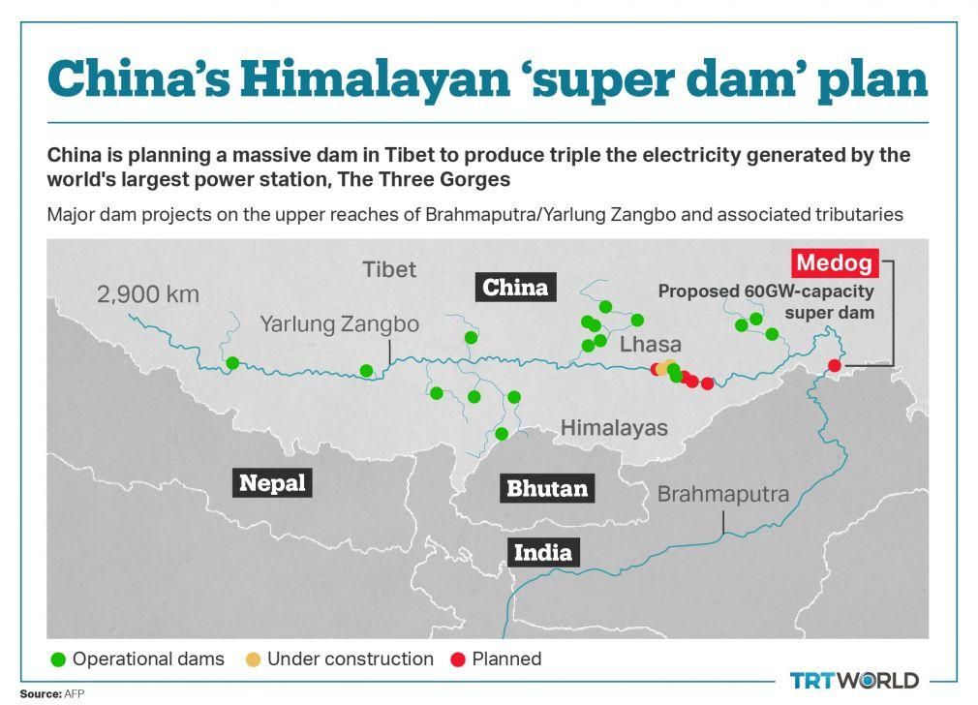
The ‘super dam’, Medog, is located at the upper course of the Brahmaputra River.
Resource 4 for Question 1
Sustainable Development Goal (SDG) indicator 7.2.1 on share of final energy use that comes from renewable sources in 2020
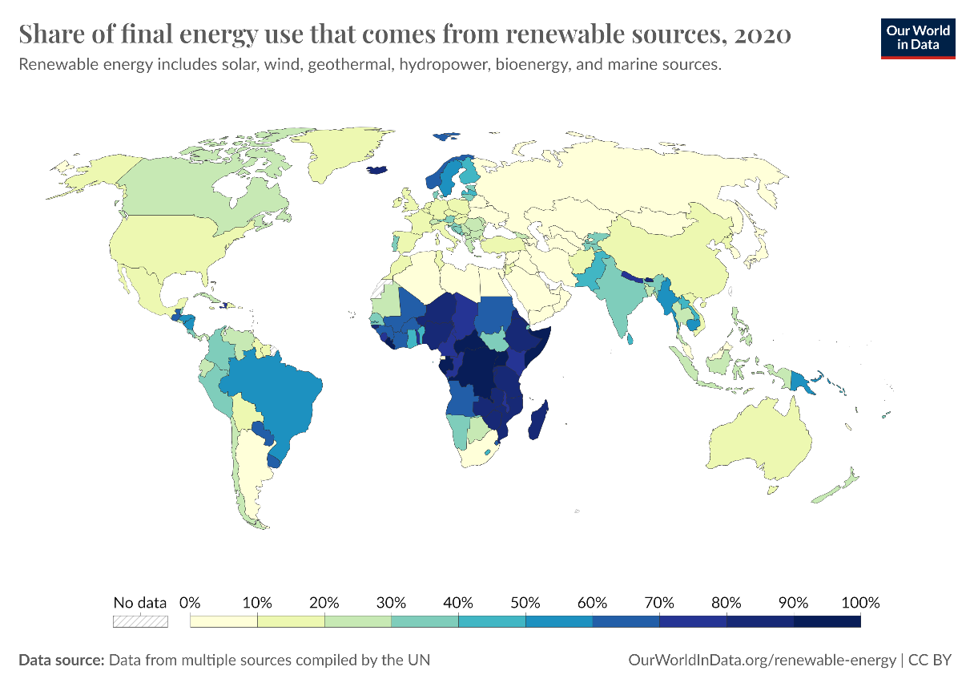
Resource 5 for Question 2
Climograph of Pathein, Myanmar (17°N, 95°E)
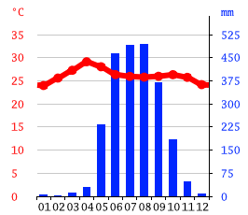

Resource 6 for Question 2
Summer and winter monsoon circulations in humid tropical Asia
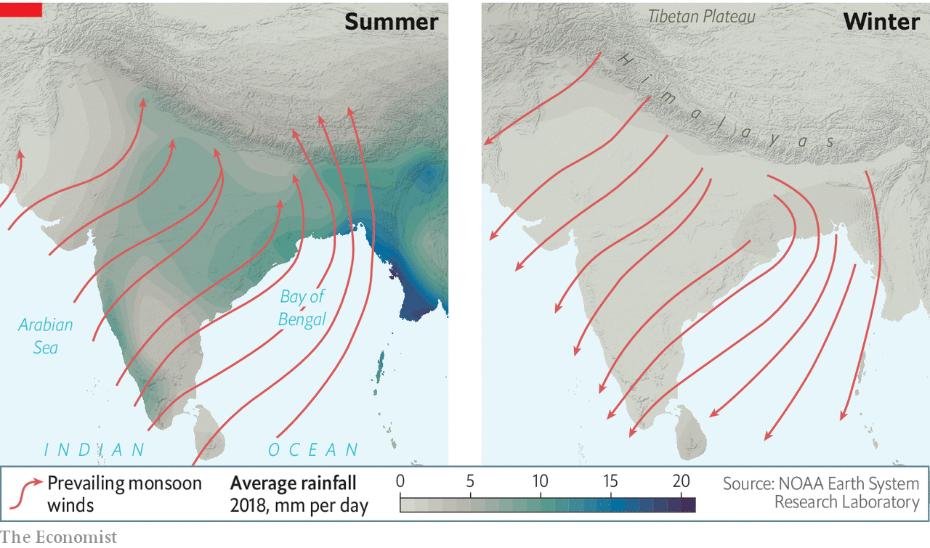
Location of Pathein, Myanmar

Tropic of Cancer
Tropic of Cancer

Resource 7 for Question 2
Tropical cyclone Mocha (May 2023)
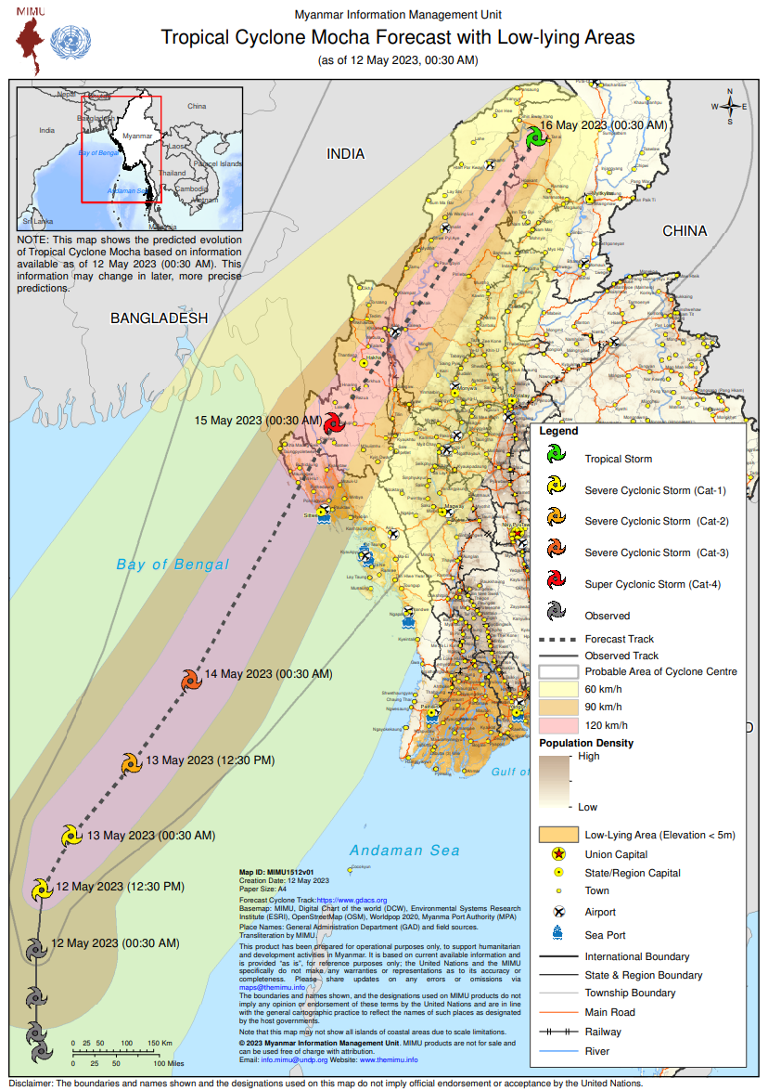
Resource 8 for Question 2
Land cover of the Irrawaddy Delta in 1974 and 2021

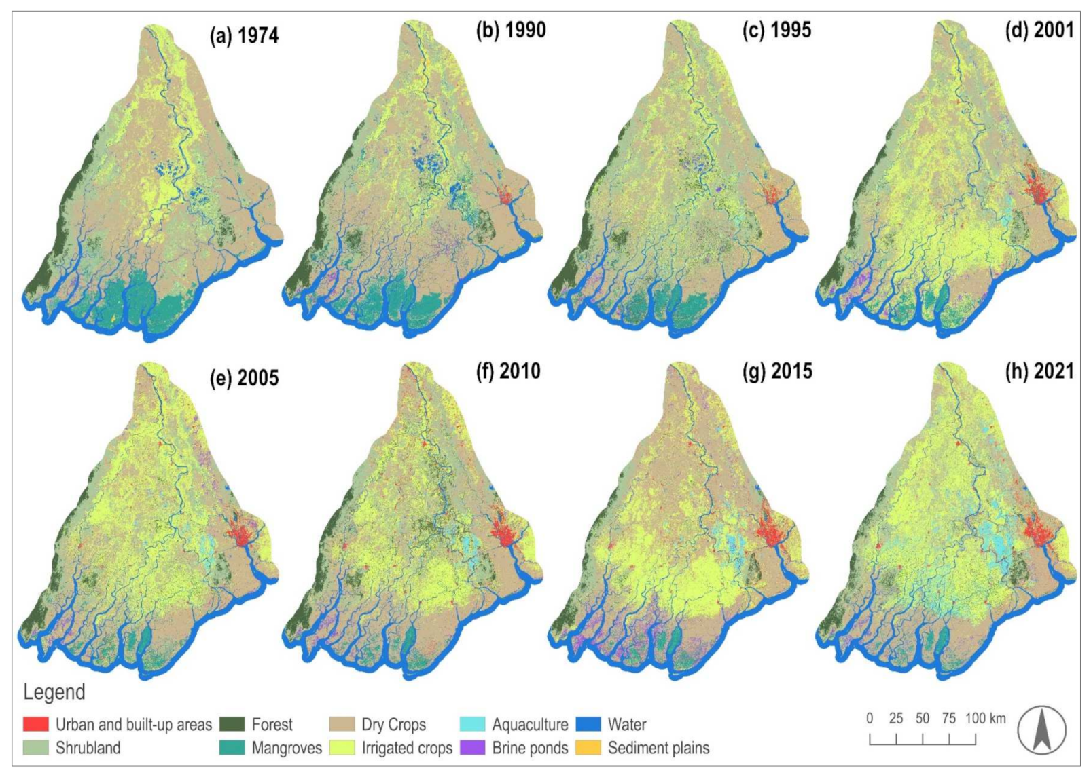

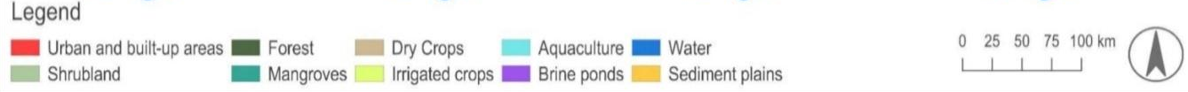

Question 1 Resource 1 | © The Economist Newspaper. (2016). Indian solar power. The Economist. https://www.economist.com/graphic-detail/2016/06/06/indian-solar-power
Question 1 Resource 2 | © Varanasi, A. (2020, June 6). India is using more solar energy-but it carries a lead risk. Wired. https://www.wired.com/story/india-is-using-more-solar-energy-but-it-carries-a-lead-risk/
Question 1 Resource 3 | © China’s Super Hydropower Dam and fears of Sino-Indian water wars. AsiaGlobal Online Journal. (2022). https://www.asiaglobalonline.hku.hk/chinas-super-hydropower-dam-and-fears-sino-indian-water-wars
Question 1 Resource 4 | © Share of primary energy consumption from renewable sources. Our World in Data. (2023). https://ourworldindata.org/grapher/renewable-share-energy
Question 2 Resource 5 | © Climate-data.org (n.d.). Climate: Ayeyarwady. https://en.climate-data.org/asia/myanmar/ayeyarwady-2295/
Question 2 Resource 6 | © The Economist Newspaper. (2019). The South Asian monsoon, past, present and future. https://www.economist.com/essay/2019/06/27/the-south-asian-monsoon-past-present-and-future
Question 2 Resource 7 | © Myanmar Information Management Unit. (2024). Cyclone Mocha. https://themimu.info/emergencies/storm_mocha_may23
Question 2 Resource 8 | © Vogel, A. et al. (2022, July 25). Identifying land-use related potential disaster risk drivers in the Ayeyarwady Delta (Myanmar) during the last 50 years (1974-2021) using a hybrid ensemble learning model. https://www.mdpi.com/2072-4292/14/15/3568

